**

Advanced Client-side Web Development

5COSC026W

Student Full Name - S. Yashwin Sivakumar

UOW ID – W2149652

IIT Number – 20232358

Tutorial group - 25

Coursework – Portfolio (individual)

Table of Contents

Code ......................................................................................................................................

home / index.html ........................................................................................................................ 2

About.html ...........................................................................................................................................4

Blog.html ..............................................................................................................................................7

Contact.html ....................................................................................................................................... 13

Style.css ..............................................................................................................................................11

Screenshots .........................................................................................................................

Home.html / index.html ...................................................................................................................... 25

About.html .......................................................................................................................................... 25

............................................................................................................................................................ 25

Blog.html ............................................................................................................................................. 26

............................................................................................................................................................ 26

............................................................................................................................................................ 26

Contact.html ....................................................................................................................................... 27

Appendix C: Screenshots - Webpage Validation Evidence ...................................................................... 27

[index.html](http://home.html/index.html)

<!DOCTYPE html>

<html lang="en">

<head>

    <meta charset="UTF-8">

    <meta name="viewport" content="width=device-width, initial-scale=1.0">

    <title>Yashwin's Portfolio</title>

    <link href='https://unpkg.com/boxicons@2.1.4/css/boxicons.min.css' rel='stylesheet'>

    <link rel="stylesheet" href="Style.css">

    <link rel="stylesheet" href="https://cdnjs.cloudflare.com/ajax/libs/font-awesome/6.4.0/css/all.min.css">

</head>

<body>

  <header class="header">

  <div class="header-container">

    <a href="index.html" class="logo">Yashwin01</a>

    <!-- Hamburger Checkbox -->

    <input type="checkbox" id="menu-toggle" class="menu-toggle">

    <label for="menu-toggle" id="menu-icon">

      <span></span>

      <span></span>

      <span></span>

    </label>

    <!-- Navigation Links -->

    <nav class="navbar">

      <a href="index.html" class="active">HOME</a>

      <a href="About.html">ABOUT</a>

      <a href="Blog.html">BLOG</a>

      <a href="Contact.html">CONTACT</a>

    </nav>

    <div class="social-icons">

  <a href="https://www.linkedin.com/in/yashwin01" class="icon" target="_blank">

    <i class='bx bxl-linkedin'></i>

  </a>

  <a href="https://github.com/yashwinsivakumar" class="icon" target="_blank">

    <i class='bx bxl-github'></i>

  </a>

  <a href="https://www.instagram.com/yaash_01._" class="icon" target="_blank">

    <i class='bx bxl-instagram'></i>

  </a>

</div>

  </div>

</header>

    <br>

    <section class="home" id="home">

        <div class="home-content">

            <h3>Hi, I'm </h3>

            <h1>Yashwin Sivakumar</h1>

            <h3>And I'm a <span class="multiple-text">Computer Science Undergraduate</span></h3>

            <p>

                I am a passionate developer building modern web and mobile applications.

            </p> <br>

                <a href="ATS-Friendly-CV.pdf" class="btn" download> Download CV</a>

        </div>

        <div class="home-img">

            <img src="images/picme1.jpg" alt="userimg">

        </div>

    </section>

    <footer class="footer">

  <div class="footer-text">

    <p>

      Copyright &copy; 2025

      <span id="Yash">

        <i class="fas fa-heart" style="color: crimson; margin-right: 0.3rem;"></i>

        Yashwin

      </span>

      | All Rights Reserved.

    </p>

  </div>

</footer>

</body>

</html>

About.html

<!DOCTYPE html>

<html lang="en">

<head>

    <meta charset="UTF-8">

    <meta name="viewport" content="width=device-width, initial-scale=1.0">

    <title>Yashwin's Portfolio</title>

    <link href='https://unpkg.com/boxicons@2.1.4/css/boxicons.min.css' rel='stylesheet'>

    <link rel="stylesheet" href="Style.css">

    <link rel="stylesheet" href="https://cdnjs.cloudflare.com/ajax/libs/font-awesome/6.4.0/css/all.min.css" >

</head>

<body>

    <header class="header">

      <div class="header-container">

        <a href="index.html" class="logo">Yashwin01</a>

        <!-- Hamburger Checkbox -->

        <input type="checkbox" id="menu-toggle" class="menu-toggle">

        <label for="menu-toggle" id="menu-icon">

          <span></span>

          <span></span>

          <span></span>

        </label>

        <!-- Navigation Links -->

        <nav class="navbar">

          <a href="index.html">HOME</a>

          <a href="About.html" class="active">ABOUT</a>

          <a href="Blog.html" >BLOG</a>

          <a href="Contact.html">CONTACT</a>

        </nav>

       <div class="social-icons">

  <a href="https://www.linkedin.com/in/yashwin01" class="icon" target="_blank">

    <i class='bx bxl-linkedin'></i>

  </a>

  <a href="https://github.com/yashwinsivakumar" class="icon" target="_blank">

    <i class='bx bxl-github'></i>

  </a>

  <a href="https://www.instagram.com/yaash_01._" class="icon" target="_blank">

    <i class='bx bxl-instagram'></i>

  </a>

</div>

      </div>

    </header>

    <div class="about-heading-wrapper">

      <h2 class="heading center-heading">About <span>Me</span></h2>

    </div>

    <section class="about" id="about">

      <div class="about-flex custom-about-layout">

        <div class="about-left">

          <h3 class="webdev-title">Web Developer</h3>

          <p>

            I’m a second-year BSc Computer Science student and web developer, skilled in HTML, CSS, React, Tailwind CSS, and modern JavaScript.

            Passionate about building interactive web and mobile applications, with interests in AI, machine learning, and data science.

          </p>

        </div>

        <div class="about-right">

          <div class="about-stats">

            <div class="stat">

              <div class="stat-icon">

                <i class="fas fa-graduation-cap"></i>

              </div>

              <div class="stat-number">B.Sc. in Computer Science</div>

              <div class="stat-text">Degree</div>

            </div>

            <div class="stat">

              <div class="stat-icon">

                <i class="fas fa-map-marker-alt"></i>

              </div>

              <div class="stat-number">Matale</div>

              <div class="stat-text">Residence</div>

            </div>

            <div class="stat">

              <div class="stat-icon">

                <i class="fas fa-university"></i>

              </div>

              <div class="stat-number">Informatics Institute of Technology</div>

              <div class="stat-text">University</div>

            </div>

            <div class="stat">

              <div class="stat-icon">

                <i class="fas fa-flag"></i>

              </div>

              <div class="stat-number">Sri Lanka <span class="flag">🇱🇰</span></div>

              <div class="stat-text">Country</div>

            </div>

          </div>

        </div>

      </div>

    </section>

    <footer class="footer">

  <div class="footer-text">

    <p>

      Copyright &copy; 2025

      <span id="Yash">

        <i class="fas fa-heart" style="color: crimson; margin-right: 0.3rem;"></i>

        Yashwin

      </span>

      | All Rights Reserved.

    </p>

  </div>

</footer>

</body>

</html>

Blog.html

<!DOCTYPE html>

<html lang="en">

<head>

    <meta charset="UTF-8">

    <meta name="viewport" content="width=device-width, initial-scale=1.0">

    <title>Yashwin's Portfolio</title>

    <link href='https://unpkg.com/boxicons@2.1.4/css/boxicons.min.css' rel='stylesheet'>

    <link rel="stylesheet" href="Style.css">

    <link rel="stylesheet" href="https://cdnjs.cloudflare.com/ajax/libs/font-awesome/6.4.0/css/all.min.css">

</head>

<body>

    <header class="header">

  <div class="header-container">

    <a href="index.html" class="logo">Yashwin01</a>

    <!-- Hamburger Checkbox -->

    <input type="checkbox" id="menu-toggle" class="menu-toggle">

    <label for="menu-toggle" id="menu-icon">

      <span></span>

      <span></span>

      <span></span>

    </label>

    <!-- Navigation Links -->

    <nav class="navbar">

      <a href="index.html">HOME</a>

      <a href="About.html">ABOUT</a>

      <a href="Blog.html" class="active">BLOG</a>

      <a href="Contact.html">CONTACT</a>

    </nav>

    <div class="social-icons">

  <a href="https://www.linkedin.com/in/yashwin01" class="icon" target="_blank">

    <i class='bx bxl-linkedin'></i>

  </a>

  <a href="https://github.com/yashwinsivakumar" class="icon" target="_blank">

    <i class='bx bxl-github'></i>

  </a>

  <a href="https://www.instagram.com/yaash_01._" class="icon" target="_blank">

    <i class='bx bxl-instagram'></i>

  </a>

</div>

  </div>

</header>

    <br>

        <section class="portfolio" id="portfolio">

        <h2 class="heading"> Latest <span>Projects</span></h2>

        <!-- Main card container wrapping all project cards -->

        <div class="card-container">

            <div class="portfolio-container">

                <div class="portfolio-box">

                    <div class="item-card">

                        <div class="portfolio-img">

                            <img src="images/sdg.png" alt="Project Thumbnail">

                        </div>

                    </div>

                    <a href="projects/SDG_website.pdf" class="btn view-btn" target="_blank">View Project</a>

                </div>

                <div class="portfolio-box">

                    <div class="item-card">

                        <div class="portfolio-img">

                            <img src="images/portfolio.png" alt="Project Thumbnail">

                        </div>

                    </div>

                    <a href="https://yashwinsportfolio.vercel.app/" class="btn view-btn" target="_blank">View Project</a>

                </div>

                <div class="portfolio-box">

                    <div class="item-card">

                        <div class="portfolio-img">

                            <img src="images/taskmanager.png" alt="Project Thumbnail">

                        </div>

                    </div>

                    <a href="projects/Task_Manager.pdf" class="btn view-btn" target="_blank">View Project</a>

                </div>

            </div>

            <br><br>

            <h2 class="blog-heading"> BLOG <span>POSTS</span></h2>

            <div class="blog-container">

                <div class="blog-box">

                    <div class="item-card">

                        <div class="blog-img">

                            <img src="images/AI.png" alt="Blog Thumbnail">

                        </div>

                        <div class="blog-text">

                            <span>Artificial Intelligence • October 2025</span>

                            <h3 class="blog-title">The Human Side of Artificial Intelligence</h3>

                            <p>Explore how AI is transforming daily life while maintaining a balance between technology and humanity. This post discusses real-world applications and the ethical dimensions of intelligent systems.</p>

                        </div>

                    </div>

                    <a href="https://medium.com/@yashwin12114/how-ai-is-quietly-changing-our-everyday-lives-515674ab2ccd" class="btn view-btn" target="_blank">View Blog</a>

                </div>

                <div class="blog-box">

                    <div class="item-card">

                        <div class="blog-img">

                            <img src="images/ML.png" alt="Blog Thumbnail">

                        </div>

                        <div class="blog-text">

                            <span>Machine Learning • October 2025</span>

                            <h3 class="blog-title">Teaching Computers to Think Smarter</h3>

                            <p>Discover how Machine Learning enables computers to learn from data, recognize patterns, and make predictions — shaping smarter systems that evolve through experience.</p>

                        </div>

                    </div>

                    <a href="https://medium.com/@yashwin12114/machine-learning-teaching-computers-to-think-smarter-63285fb8ea53" class="btn view-btn" target="_blank">View Blog</a>

                </div>

            </div>

        </div>

        </section>

    <footer class="footer">

  <div class="footer-text">

    <p>

      Copyright &copy; 2025

      <span id="Yash">

        <i class="fas fa-heart" style="color: crimson; margin-right: 0.3rem;"></i>

        Yashwin

      </span>

      | All Rights Reserved.

    </p>

  </div>

</footer>

<br>

</body>

</html>

Contact.html

<!DOCTYPE html>

<html lang="en">

<head>

    <meta charset="UTF-8">

    <meta name="viewport" content="width=device-width, initial-scale=1.0">

    <title>Yashwin's Portfolio</title>

    <link href='https://unpkg.com/boxicons@2.1.4/css/boxicons.min.css' rel='stylesheet'>

    <link rel="stylesheet" href="Style.css">

    <link rel="stylesheet" href="https://cdnjs.cloudflare.com/ajax/libs/font-awesome/6.4.0/css/all.min.css">

</head>

<body>

    <header class="header">

  <div class="header-container">

    <a href="index.html" class="logo">Yashwin01</a>

    <!-- Hamburger Checkbox -->

    <input type="checkbox" id="menu-toggle" class="menu-toggle">

    <label for="menu-toggle" id="menu-icon">

      <span></span>

      <span></span>

      <span></span>

    </label>

    <!-- Navigation Links -->

    <nav class="navbar">

      <a href="index.html">HOME</a>

      <a href="About.html">ABOUT</a>

      <a href="Blog.html">BLOG</a>

      <a href="Contact.html" class="active">CONTACT</a>

    </nav>

    <div class="social-icons">

  <a href="https://www.linkedin.com/in/yashwin01" class="icon" target="_blank">

    <i class='bx bxl-linkedin'></i>

  </a>

  <a href="https://github.com/yashwinsivakumar" class="icon" target="_blank">

    <i class='bx bxl-github'></i>

  </a>

  <a href="https://www.instagram.com/yaash_01._" class="icon" target="_blank">

    <i class='bx bxl-instagram'></i>

  </a>

</div>

  </div>

</header>

   <section class="contact" id="contact">

    <h2 class="heading">Contact <span>Me!</span></h2>

    <p class="contact-intro">

    I’m always open to discussing new projects, collaborations, or creative ideas.

    Let’s build something amazing together!

  </p>

    <div class="contact-card">

        <div class="input-card">

            <input type="text" placeholder="Full Name">

        </div>

        <div class="input-card">

            <input type="email" placeholder="Your Email">

        </div>

        <div class="input-card">

            <input type="text" placeholder="Subject">

        </div>

        <div class="input-card">

            <textarea cols="30" rows="8" placeholder="Your Message"></textarea>

        </div>

        <input type="button" value="Send Message" class="btn" onclick="location.href='mailto:yashwin12114@gmail.com';">

    </div>

</section>

   <footer class="footer">

  <div class="footer-text">

    <p>

      Copyright &copy; 2025

      <span id="Yash">

        <i class="fas fa-heart" style="color: crimson; margin-right: 0.3rem;"></i>

        Yashwin

      </span>

      | All Rights Reserved.

    </p>

  </div>

</footer>

</body>

</html>

Style.css

Screenshots

[index.html](http://home.html/index.html)

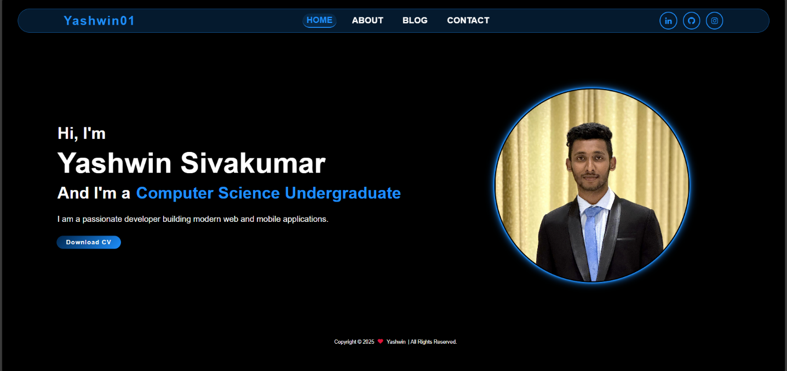

About.html

Blog.html

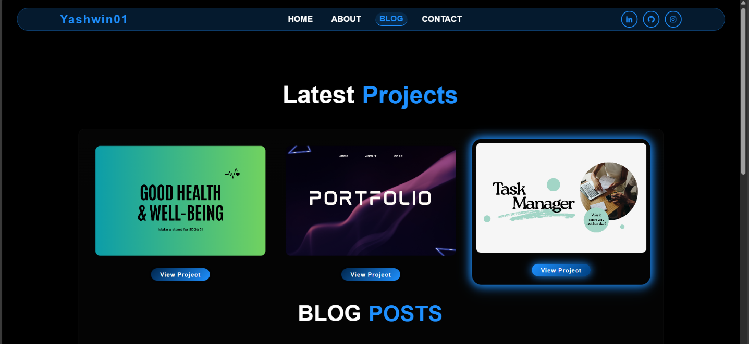

Contact.html

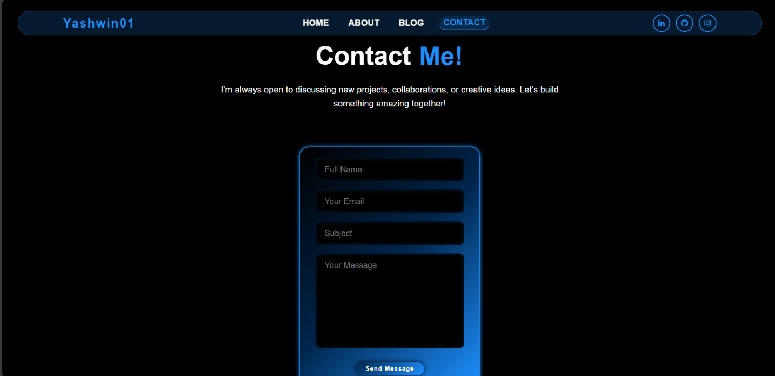

Screenshots - Validation

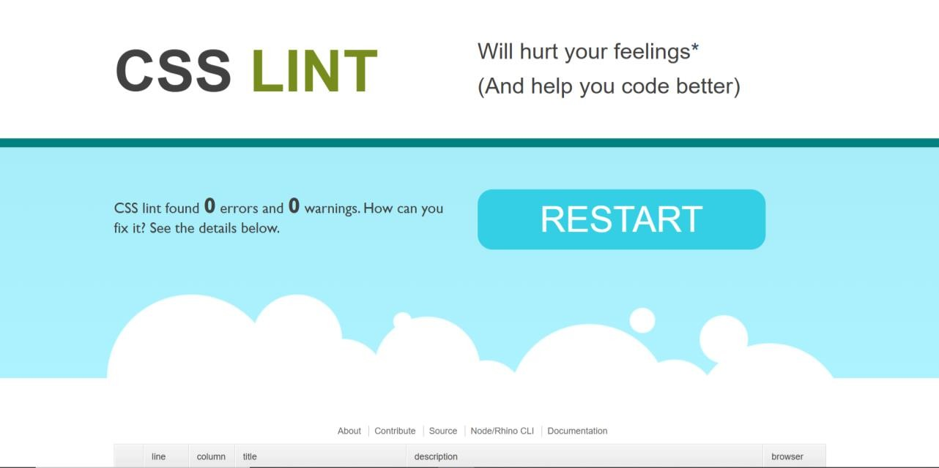

GitHub Repository

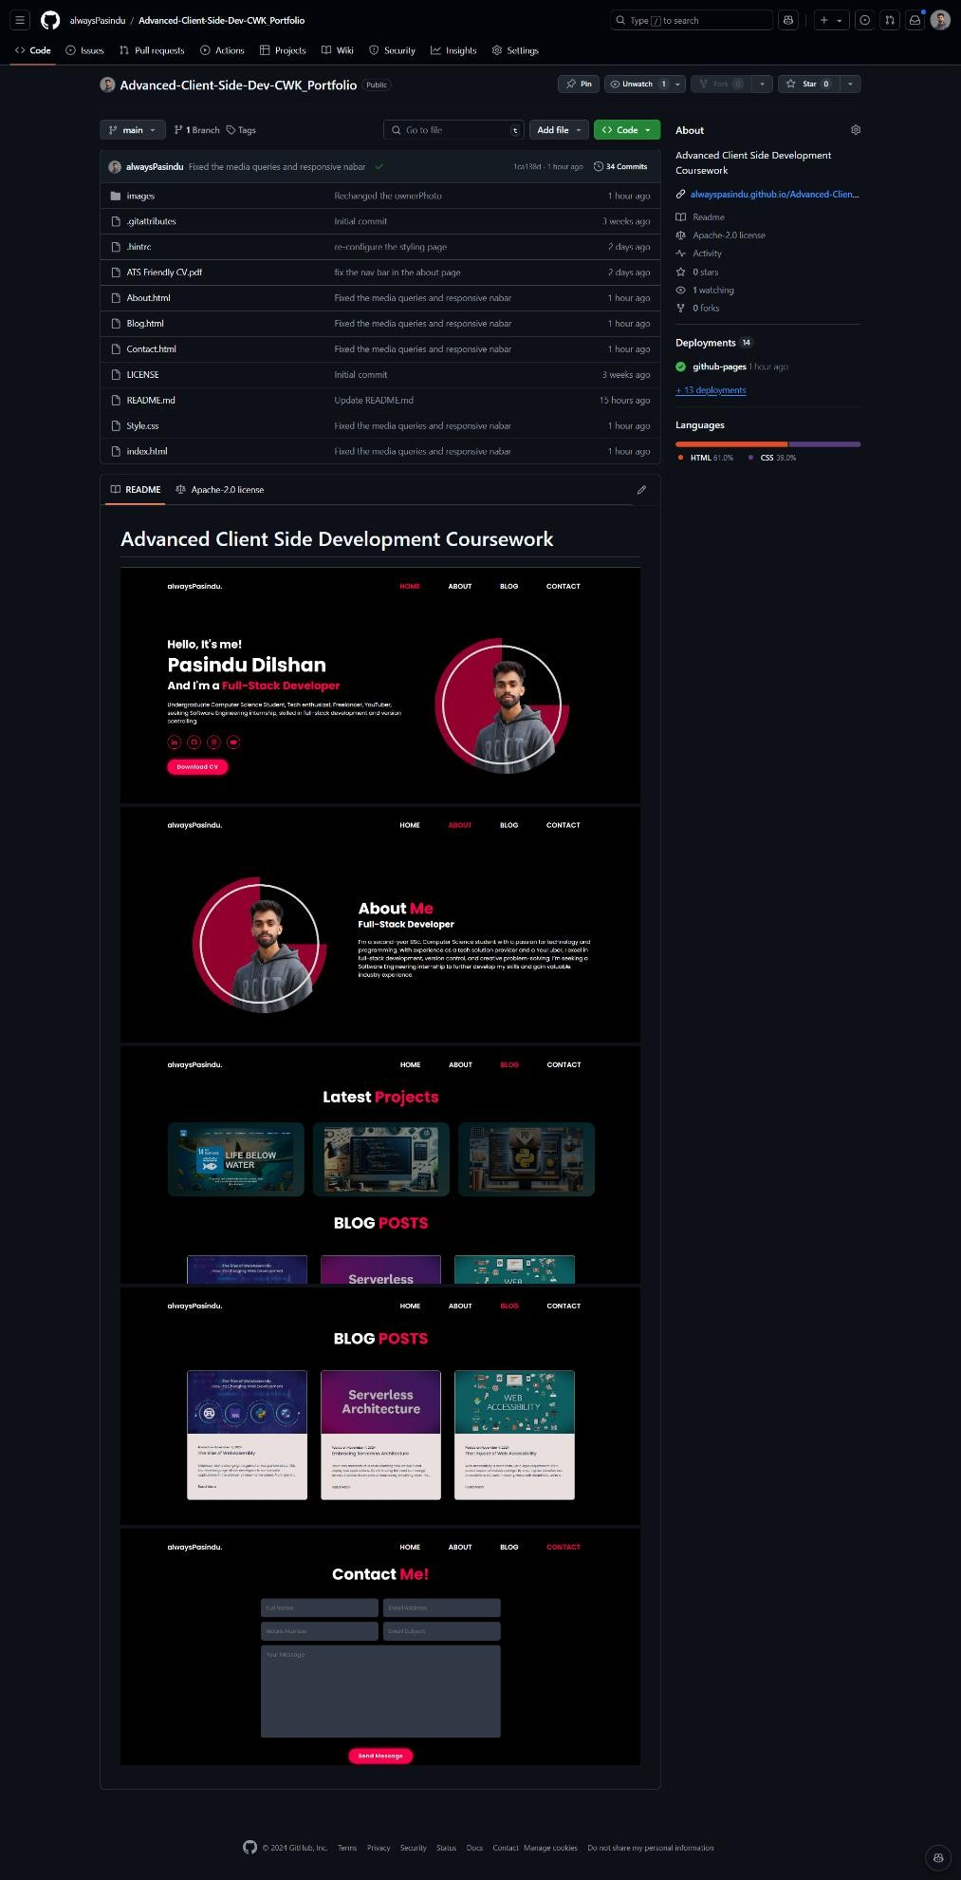

GitHub Commit History

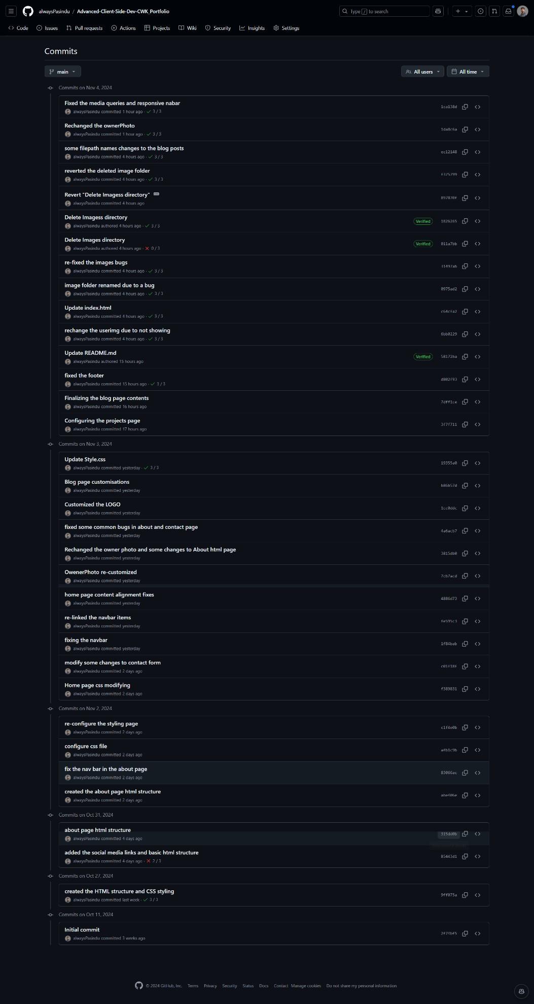

Lighthouse Report (Desktop)



